**A PROJECT REPORT**

on

**INTERNET OF THINGS BASED AUTONOMOUS BOREWELL MANAGEMENT SYSTEM**

*Submitted in partial fulfilment for the award of the degree*

of

**BACHELOR OF TECHNOLOGY**

in

**ELECTRICAL AND ELECTRONICS ENGINEERING**

For

21EEP302L - Project

by

**Rethu Nandan [RA2211005010038]**

**Pavansanjay S [RA2211005010011]**

**Himanshu Yadav [RA2211005010015]**

*Under the guidance of*

**Dr. Sridhar R**

(Head Of The Department, Department of Electrical and Electronics Engineering)



**FACULTY OF ENGINEERING AND TECHNOLOGY**

SRM Nagar, Kattankulathur- 603 203

Chengalpattu Dist.

**MAY 2025**

**BONAFIDE CERTIFICATE**

Certified that this project report titled “internet of things based autonomous borewell management system” is the Bonafide work of who carried out the project work under my supervision. Certified further, that to the best of my knowledge the work reported herein does not form part of any other project report or dissertation on the basis of which a degree or award was conferred on an earlier occasion of this or any other candidate.

Signature of the Faculty In charge Signature of the Head of the Department

**Dr. Sridhar R Dr. Sridhar R**

(Head of the Department) (Head of the Department)

Internal Examiner External Examiner

Date:

#### **ACKNOWLEDGEMENT**

We express our humble gratitude to **Dr. C. Muthamizhchelvan**, **Vice-Chancellor, SRM Institute of Science and Technology**, for the facilities extended for the project work and his continued support.

We extend our sincere thanks to **Dr. K. Vijayakumar, Chairperson**, School of Electrical and Electronics Engineering, SRM Institute of Science and Technology, for his invaluable support and guidance throughout the project duration.

We are extremely grateful to **Dr. Sridhar R, Professor and Head of the Department** of Electrical and Electronics Engineering, SRM Institute of Science and Technology, for his consistent motivation, timely advice, and encouragement that greatly contributed to the successful completion of our project.

We would like to express our heartfelt thanks to our project guide, **Dr. Narayanamoorthi R,** Assistant Professor, Department of Electrical and Electronics Engineering, SRM Institute of Science and Technology, for his unwavering support, insightful suggestions, and guidance throughout the course of our project. His expertise, vision, and dedication inspired us to work diligently and complete our project successfully.

We also convey our sincere thanks to all the faculty members of the Department of Electrical and Electronics Engineering, SRM Institute of Science and Technology, for their support and assistance during the development of our project.

Finally, we extend our deepest gratitude to our parents, family, and friends for their constant love, patience, and encouragement which made this work possible.

RETHU NANDAN

PAVAN SANJAY

HIMANSHU YADAV

Author

**ABSTRACT**

Water is an essential resource for all forms of life, yet urban areas are witnessing a rapid decline in groundwater levels due to increasing population and demand. During summer, the scarcity of continuous water supply becomes critical. In many cases, borewell motors continue to operate during dry run conditions, leading to unnecessary power consumption, damage to motor windings, and increased operational costs.

Addressing energy conservation at the individual level through automation is crucial in such scenarios. This paper proposes an Internet of Things (IoT)-based borewell control system designed to automate scheduling, enable manual overrides, and prevent motor operation during water scarcity. By monitoring electrical parameters and utilizing real-time data, the system ensures efficient remote operation and management.

The proposed solution minimizes energy loss, reduces manpower requirements, and enhances the reliability of borewell usage through the deployment of smart controllers and integrated communication technologies***.*** The system architecture includes microcontrollers, water level sensors, current sensors, and GSM/Wi-Fi modules to ensure flexible communication and adaptive response. In addition, user interfaces such as mobile applications or SMS-based commands allow users to monitor and control the system remotely.

This automated approach not only promotes sustainable water usage but also contributes to long-term cost savings and resource optimization. It serves as a scalable and practical model for both residential and agricultural water management systems.

**TABLE OF CONTENTS**

|  |  |  |
| --- | --- | --- |
| **CHAPTER** | **TITLE**  **ABSTRACT**  **LIST OF FIGURES**  **LIST OF TABLES** | **PAGE NO.** |
| 1 | **INTRODUCTION** | 1 |
|  | 1.1 INTRODUCTION TO THE PROJECT | 1 |
|  | 1.2 PROBLEM STATEMENT | 2 |
|  | 1.3 OBJECTIVES | 3 |
|  | 1.4 MOTIVATION | 4 |
|  | 1.5 SUSTAINABLE DEVELOPMENT GOAL OF THE PROJECT | 5 |
| 2 | LITERATURE SURVEY | 6 |
|  | 2.1 OVERVIEW OF THE RESEARCH AREA | 6 |
|  | 2.2 RESEARCH LIMITATIONS AND UNADDRESSED CHALLENGES | 7 |
|  | 2.3 KEY OBJECTIVES OF THE RESEARCH | 8 |
|  | 2.4 USER-CENTERED FEATURES AND EXPECTED OUTCOMES | 9 |
|  | 2.5 STEP-BY-STEP EXECUTION PLAN | 10 |
| 3 | SYSTEM ARCHITECTURE AND DESIGN OVERVIEW | 11 |
|  | 3.1 OVERVIEW OF THE SYSTEM ARCHITECTURE | 11 |
|  | 3.2 CIRCUIT DEVELOPMENT OVERVIEW | 13 |
|  | 3.3 OPERATIONAL MECHANISM OF THE BOREWELL MONITORING SYSTEM | 14 |
|  | 3.4 HARDWARE INTEGRATION | 15 |
|  | 3.5 ELECTRICAL CIRCUIT AND ESP32 PIN CONFIGURATION TABLE | 16 |
|  | 3.6 SYSTEM ARCHITECTURE AND FUNCTIONAL ROLES | 17 |
|  | 3.7 INTEGRATION OF BLYNK IOT PLATFORM FOR REMOTE WATER LEVEL MONITORING | 18 |
| 4 | SIMULATION AND RESULTS | 20 |
|  | 4.1 SIMULATIONS OF THE SYSTEM IN DIFFERENT SCENARIOS | 20 |
| 5 | IMPLEMENTATION | 22 |
|  | 5.1 PRACTICAL IMPLEMENTATION OF THE PROPOSED SYSTEM | 22 |
| 6 | CONCLUSION | 24 |
| 7 | REFERENCES | 25 |

**TABLE OF FIGURES**

| **FIGURE NO.** | **TITLE** | **PAGE NO.** |
| --- | --- | --- |
| 3.1 | BLOCK DIAGRAM OF BOREWELL MONITORING SYSTEM | 11 |
| 3.4 | FLOWCHART OF THE WORKING | 14 |
| 3.5 | CIRCUIT DIAGRAM OF BOREWELL MONITORING | 16 |
| 3.6 | REAL-TIME CIRCUIT | 17 |

**LIST OF TABLES**

| **TABLE NO.** | **TITLE** | **PAGE NO.** |
| --- | --- | --- |
| 3.5 | ESP32 PIN CONFIGURATION TABLE | 16 |
| 3.7 I | OLED DISPLAY VALIDATION | 20 |
| 3.7 II | SIMULATION OF THE PUMP IN REAL TIME | 21 |
| 3.7 III | BLYNK NOTIFICATION RESPONSE TEST | 21 |

**CHAPTER I**

**INTRODUCTION**

* 1. **INTRODUCTION TO THE PROJECT**

Many kinds of customers are using excessive amounts of water on our globe. Utilization, waste, and improper use are also included. Sustainability issues will eventually surface. In various parts of the world, water scarcity is caused by by the fluctuations in the temperature, the amount of pollutants, human overconsumption, and the usage of water beyond what is necessary. About 15% of water pump failures are caused by dry run because of inadequate protective systems.

When implementation process; the third section further elaborates on the system integration; and the final section presents conclusions and outlines future work. The total amount of water available on Earth has been estimated at 1.4 billion cubic the motor is operating but not pumping, this failure happens. This causes voltage fluctuations but also a highly loaded state that causes the motor to overheat and lose a significant amount of power. Therefore, we give the motor some smart controllers to prevent the problem. Therefore, by detecting the current value, the motor can determine whether it is running or not, turning on and off to prevent damage. By doing this, we avoid power outages and so save energy.

The Internet of Things, or IoT, has developed, evolved, and is onected to nearly every physical system. The potential for prosumer profit is being shown by digital twins and multi-domain integration. In essence, a bore-well is a hydro system powered by an electrical source. It will become fully autonomous and intelligent when IoT devices are integrated at the appropriate locations. Moreover, such systems have industrial applications, particularly in monitoring the levels of hazardous fluids that require strict oversight.

The system also includes an automated tank filling mechanism, which activates when water supply is available and halts once the tank reaches a predefined level. This control is achieved through an Arduino microcontroller integrated with sensors, a display module, and a Bluetooth chip. Each hardware component is managed via dedicated C-language libraries to ensure seamless operation and achieve the intended goal of smart reservoir management.

The system ensures optimal water usage km, enough to cover the planet with a layer of about 3 km. About 95% of the Earth’s water is in the oceans, which is unfit for human consumption. Researchers have estimated that by 2025 more than half of the world population will face water shortages. A study estimated that a person in India consumes an average of 135 litres per day. This consumption would rise by 40% by the year 2025. This signifies the need to preserve our fresh water resources.

* 1. **PROBLEM STATEMENT**

With increasing urbanization and rising water demand, managing groundwater resources effectively has become a growing concern. Conventional borewell systems require manual operation to switch motors on or off, often relying on human judgment without real-time insight into water availability or motor status. This manual dependency leads to inefficiencies such as motors running during dry conditions, causing energy wastage, potential damage to equipment, and higher maintenance costs. Moreover, inconsistent monitoring can result in over-extraction or unavailability of water during peak demand periods, especially in areas prone to seasonal water shortages.

This project focuses on automating borewell management using an Internet of Things (IoT)-based system that enables intelligent control and monitoring of borewell operations. The system integrates sensors to detect water availability and motor status, microcontrollers for processing, and communication modules (like GSM/Wi-Fi) to relay real-time data to users.

* 1. **OBJECTIVES**

• Design an automated borewell control system to eliminate manual motor operation and monitoring.

• Integrate water level and current sensors to detect dry run conditions and prevent motor damage.

• Employ microcontrollers and IoT modules (ESP32/GSM/Wi-Fi) for real-time data acquisition and

communication.

• Enable remote motor control and scheduling via a mobile app or SMS interface.

• Monitor electrical parameters to ensure energy-efficient operation and system health.

• Trigger alerts or notifications to users during abnormal events or completion of scheduled operation.

• Simulate system performance and behavior using tools like MATLAB/Proteus.

• Develop a scalable,low-cost, and user-friendly prototype suitable for both residential and agricultural.

* 1. **MOTIVATION**

The growing strain on water resources, particularly in urban and semi-urban regions, has highlighted the critical need for intelligent water management solutions. Borewells are commonly used as a primary water source; however, their manual operation often results in significant inefficiencies such as energy wastage, motor damage due to dry running, and inconsistent water availability. These challenges are exacerbated during peak summer months when groundwater levels decline and timely water supply becomes crucial.

This project is driven by the need to automate and optimize borewell operations using Internet of Things (IoT) technologies. Our solution involves deploying smart controllers integrated with water level sensors, current sensors, and communication modules (GSM/Wi-Fi) to enable real-time monitoring and remote operation. The system can automatically detect water availability, prevent motor operation during dry runs, and allow scheduled or manual control via a user-friendly mobile interface or SMScommands.

By merging sensor intelligence with network connectivity, the system ensures efficient power usage, reduces the risk of motor burnout, and eliminates the need for constant human supervision. Users receive real-time alerts and data insights, enabling informed decision-making and proactive maintenance.

Inspired by automation principles used in smart agriculture and home automation, this project translates similar benefits—such as reliability, cost-effectiveness, and operational ease—into the context of water resource management. The research also explores low-cost, scalable deployment methods, making the system suitable for both rural households and urban communities, where smart water usage is becoming an environmental and economic priority.

**1.5 SUSTAINABLE DEVELOPMENT GOAL OF THE PROJECT**

This project aligns with the United Nations Sustainable Development Goals (SDGs), particularly SDG 6: *Clean Water and Sanitation* and SDG 7: *Affordable and Clean Energy.* By automating borewell operations, it ensures efficient water usage and prevents unnecessary motor activity during dry conditions, thereby conserving both water and energy. The system promotes responsible resource consumption, especially in areas facing seasonal water scarcity or erratic groundwater levels.

Additionally, the integration of IoT and smart monitoring supports SDG 9: *Industry, Innovation and Infrastructure* by introducing low-cost automation into essential water infrastructure. This encourages the development of scalable, intelligent solutions forsmart homes, farms, and communities, paving the way for sustainable and tech-driven resource management.

**CHAPTER II**

**LITERATURE SURVEY**

**2.1 OVERVIEW OF THE RESEARCH AREA**

The research focuses on the application of Internet of Things (IoT) and automation technologies to enhance the efficiency, reliability, and sustainability of borewell water management systems. With the growing demand for water and the frequent depletion of groundwater levels, traditional manually operated borewells are proving to be inefficient and resource-intensive. This area of research aims to tackle issues such as dry run motor damage, energy wastage, and inconsistent water availability through real-time monitoring, sensor integration, and remote-control capabilities.

By leveraging microcontrollers, water level sensors, current sensors, and wireless communication modules, the study explores a system that can autonomously manage borewell operations. This research contributes to the broader field of smart infrastructure and sustainable resource management, demonstrating how low-cost, sensor-based automation can make critical utilities more intelligent, user-friendly, and environmentally responsible

**2.2 RESEARCH LIMITATIONS AND UNADDRESSED CHALLENGES FROM LITERATURE REVIEW**

Despite numerous advancements in borewell automation, several limitations persist in existing systems. Most studies focus on basic motor control using timers or manual switches, lacking real-time adaptability based on water availability or electrical parameters. Dry run protection is either absent or implemented using inefficient, delay-prone methods that do not account for dynamic environmental conditions.

Furthermore, many proposed solutions do not incorporate remote monitoring capabilities, which limits scalability and user convenience—especially in rural areas where borewells are often located far from the residence. Existing models also tend to rely on costly or overly complex architectures, making them less accessible for low-income or small-scale users. The integration of user alerts, data logging, and intuitive interfaces is also generally overlooked, restricting the system’s practical usability and long-term maintenance.

These gaps highlight the need for a smart, affordable, and user-friendly borewell management system that integrates real-time data, remote control, and energy-efficient operation tailored to variable water conditions.

**2.3 KEY OBJECTIVES OF THE RESEARCH**

* **To design and develop an automated borewell control system that minimizes human intervention**
* **To detect dry run conditions using sensors and prevent motor damage through timely shutdown.**
* **To implement real-time monitoring and control using microcontrollers and IoT communication modules (e.g., ESP32, GSM).**
* **To enable remote operation and scheduling of the borewell motor via mobile application or SMS.**
* **To ensure energy-efficient motor usage by monitoring electrical parameters such as current flow.**
* **To generate user alerts and notifications for abnormal conditions and operational status.**
* **To build a scalable, cost-effective prototype suitable for deployment in both rural and urban settings.**
* **To validate the system’s performance through simulations and real-time testing.**

**2.4 USER-CENTERED FEATURES AND EXPECTED OUTCOMES**

* As a homeowner, I want the borewell motor to stop automatically during dry run conditions, so that I can avoid motor damage and reduce power wastage.
* As a remote user, I want to start or stop the motor via my mobile device, so that I can control water supply without being physically present near the borewell.
* As a system operator, I want real-time status updates and alerts, so that I am immediately informed of faults, water unavailability, or abnormal power consumption.
* As a resident in a water-scarce area, I want the system to operate only when water is available, so that I can make optimal use of limited groundwater.
* As a user with minimal technical knowledge, I want a simple interface and plug-and-play setup, so that I can use the system easily without advanced skills.

**2.5 STEP-BY-STEP EXECUTION PLAN**

* Problem Analysis & Requirement Gathering

Identify user needs, define key functionalities, and understand environmental constraints.

* Component Selection & Procurement

Choose appropriate sensors (water level, current), microcontroller (ESP32), and communication modules (GSM/SIM800L).

* System Design & Architecture

Develop circuit schematics, communication flow, and control logic for automation and remote access.

* Prototype Development

Assemble the hardware components and integrate them with programmed control algorithms.

* Software Integration

Implement firmware for sensor monitoring and motor control, and develop a mobile interface (app/SMS-based).

* Testing & Calibration

Conduct real-time testing to fine-tune sensor thresholds, verify motor control, and validate dry run detection.

* Deployment & Evaluation

Deploy in a target environment, monitor performance, and evaluate energy savings and user experience.

#### **CHAPTER III**

**SYSTEM ARCHITECTURE AND DESIGN OVERVIEW**

**3.1 OVERVIEW OF THE SYSTEM ARCHITECTURE**

The system is built around an ESP32 microcontroller, which acts as the central control unit. It receives input from a water level sensor placed inside the borewell and a current sensor connected to the motor line. These sensors detect water availability and monitor motor operation for dry run conditions. A relay module is used to switch the borewell motor ON/OFF based on the sensor inputs.

For remote communication, the system uses a SIM800L GSM module, enabling the user to control the motor via SMS commands and receive status alerts. Alternatively, Wi-Fi-based control can be provided where internet access is available. The system supports manual override, scheduled operation, and real-time feedback, ensuring flexibility and user convenience

All components are housed in a weather-resistant enclosure, and the system is powered by a 12V or 18650 battery-backed supply with a voltage regulator to ensure stable operation in field conditions.

**Applications:**

1. Agricultural Irrigation Control  
   Automates borewell motor operation based on soil moisture and water level, improving crop yield and conserving water.
2. Smart Residential Water Management  
   Schedules water pumping in homes to avoid dry runs and reduce electricity costs.
3. Municipal Water Supply Monitoring  
   Ensures optimized pumping in local water supply systems, especially during peak demand periods.
4. Remote Water Resource Monitoring  
   Useful for monitoring borewells in remote or unattended locations via cloud-based alerts and dashboards.
5. Industrial Water Use Optimization  
   Manages borewell usage in factories where water is essential for cooling, processing, or cleaning.
6. Disaster and Emergency Water Management  
   Provides reliable control of borewells during droughts or power shortages to prioritize critical water needs**.**

**Core Functional Highlights:**

The IoT-Based Autonomous Borewell Management System integrates multiple functionalities to ensure smart, energy-efficient, and reliable borewell operation. The key capabilities of the system include:

1. Automatic Motor Control Based on Water Availability  
   The system uses ultrasonic sensors to monitor water levels in real-time. If water falls below a predefined threshold, the motor is automatically turned off to prevent dry running and damage.
2. Real-Time Monitoring and Alerts  
   The ESP32 microcontroller collects data and transmits it to a cloud server or local display. Users receive immediate alerts via mobile apps or web interfaces about water levels, motor status, and fault conditions.
3. Manual Override and Scheduling Options  
   Users can manually activate or deactivate the borewell motor through a physical button or remotely using an app. Scheduled operations can also be programmed to match irrigation or household water needs.
4. Energy Consumption Optimization  
   The system prevents unnecessary motor operation, which not only reduces power consumption but also enhances the lifespan of the motor and reduces maintenance costs.
5. OLED Display for Local Feedback  
   An integrated OLED screen provides real-time status updates such as water level, system state, and motor activity, aiding users without internet access.
6. Fault Detection and Safety Alerts  
   The system detects abnormal conditions like sensor failure, power issues, or prolonged dry-run attempts, and sends alerts to prevent hardware damage

**3.2 CIRCUIT DEVELOPMENT OVERVIEW**

The circuit for the Automated Borewell Monitoring System was designed around the **ESP32-WROOM Dev Module**, chosen for its built-in Wi-Fi and multiple GPIO pins. Power to all components is supplied directly from the ESP32’s 5V and 3.3V outputs, eliminating the need for an external power converter. The **HC-SR04** ultrasonic sensor is used to measure the water level inside the borewell, with its Trig and Echo pins connected to GPIO D26 and D27. The sensor operates using the 5V output from the ESP32, while the logic signals are read and processed directly.

To provide real-time visual feedback, a **0.96” I2C OLED** display is connected to the ESP32 via SDA and SCL lines on GPIO D21 and D22 respectively. A buzzer and LED indicator circuit is used for water level alerts, with a **BC547 transistor** acting as a switch controlled through GPIO D13. A push-button, connected to GPIO D12 and grounded through a **220Ω** resistor, is incorporated for manual interactions like resetting or triggering alerts. All components share a common ground with the ESP32, ensuring circuit stability. This compact, ESP32-powered setup makes the system both portable and cost-effective for remote borewell monitoring.

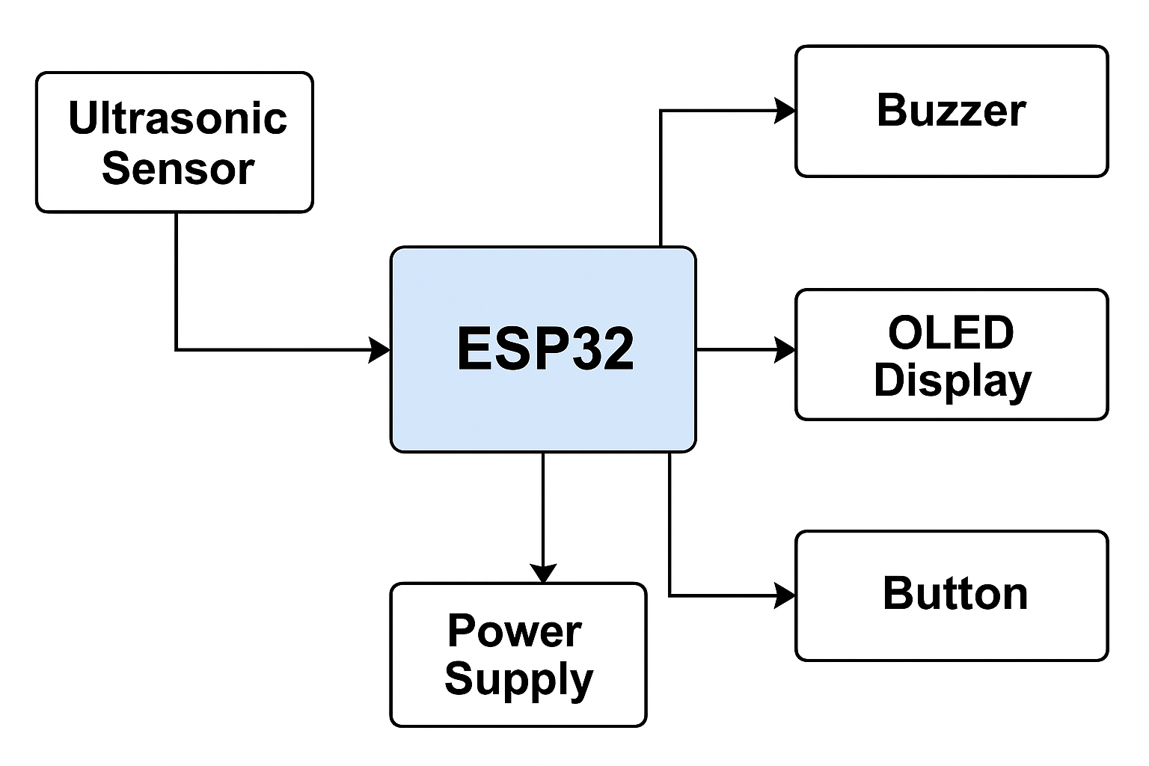

**Figure 3.2 Block diagram**

**3.3 OPERATIONAL MECHANISM OF THE BOREWELL MONITORING SYSTEM**

The automated borewell monitoring system operates by continuously detecting the water level using an ultrasonic sensor (HC-SR04), which is interfaced with the ESP32 Wroom development module. The ultrasonic sensor emits high-frequency sound waves and measures the time it takes for the echo to return after hitting the water surface. This time delay is used to calculate the distance between the sensor and the water level.

The ESP32 processes this data and determines whether the water level is below a certain threshold. If it is, the system triggers an alert mechanism using a buzzer and LED. The status is also displayed on a connected OLED screen for easy visualization. A push button is provided to reset or acknowledge the alert manually.

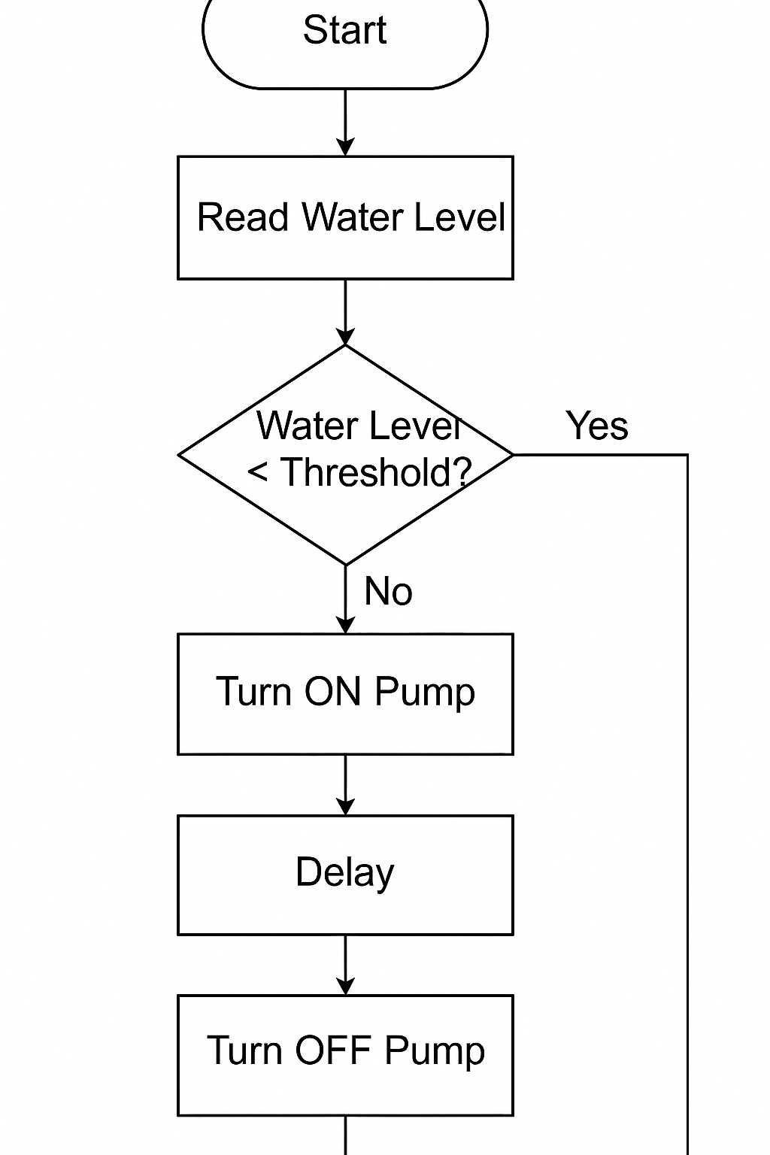The entire system is powered by the ESP32 module, eliminating the need for an external power converter. The transistor (BC547) acts as a switch to control the buzzer and LED based on the output from the ESP32, ensuring efficient operation. This setup ensures real-time monitoring and instant feedback to prevent borewell overflow or dry-run scenarios.

**Figure 3.3 Flowchart of the working**

**3.4 HARDWARE INTEGRATION**

The hardware integration of the automated borewell monitoring system involves connecting and configuring various electronic components to function seamlessly as a single unit. The core controller is the ESP32 WROOM Dev Module, which powers and manages all peripheral devices without the need for an external voltage converter.

An ultrasonic sensor (HC-SR04) is used to measure water level depth in the borewell. Its VCC and GND are powered directly from the ESP32’s 5V and GND pins, while the Trigger and Echo pins are connected to digital GPIO pins for signal transmission and reception.

A buzzer and LED are integrated through a BC547 transistor to provide alerts when water levels drop below the threshold. A push button allows manual control or system reset. Each of these components is powered and controlled through the ESP32, with appropriate resistors to limit current and protect circuits.

The OLED display is connected via the I2C protocol (SCL and SDA lines), enabling real-time visual updates of water level status. The wiring is kept compact and efficient to ensure portability and minimal power loss.

**3.5 ELECTRICAL CIRCUIT AND ESP32 PIN CONFIGURATION TABLE**

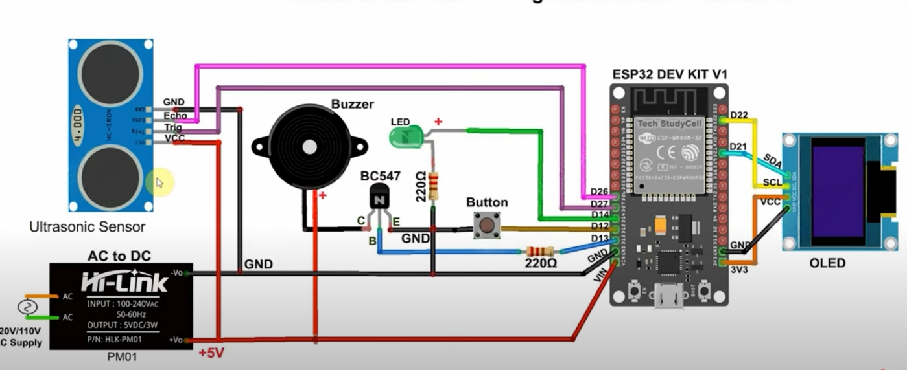

**Figure 3.5 Circuit Diagram**

|  |  |  |
| --- | --- | --- |
| **ESP32 Pin** | **Connected Component** | **Purpose** |
| **D12** | **Ultrasonic Sensor (Trig)** | **Sends ultrasonic pulse** |
| **D14** | **Ultrasonic Sensor (Echo)** | **Receives pulse to measure distance** |
| **D13** | **Button** | **Receives input from user push button** |
| **D27** | **Buzzer (via BC547 transistor)** | **Triggers buzzer alert** |
| **D26** | **LED (via BC547 transistor)** | **Controls status indication LED** |
| **D21** | **OLED Display (SDA)** | **I2C data communication** |
| **D22** | **OLED Display (SCL)** | **I2C clock communication** |
| **VIN** | **Power Source for Circuit** | **Provides 5V to the components** |
| **GND** | **Common Ground** | **Completes electrical circuit** |

**Table No. 3.5 ESP32 Pin Configuration Table**

**3.6 SYSTEM ARCHITECTURE AND FUNCTIONAL ROLES**

ESP32-WROOM Development Board

* Acts as the central control unit for the system.
* Manages all sensor inputs, display output, and actuator control.
* Supports Wi-Fi and Bluetooth for potential remote communication.

Ultrasonic Sensor (HC-SR04)

* Measures distance to detect nearby obstacles or motion.
* Sends Trigger and receives Echo signals connected to GPIO pins.
* Used to activate alert mechanisms based on proximity.

Push Button

* Allows manual activation of the alert system.
* Connected to a digital GPIO pin for interrupt-based or polled input.

Buzzer with BC547 Transistor Switch

* Provides audio alerts in emergency situations.
* Controlled via GPIO using a transistor to drive higher current.

LED Indicator

* Visual alert to indicate that the system has been triggered.
* Powered through a GPIO pin with current-limiting resistor.

OLED Display (I2C Interface)

* Shows real-time status or emergency messages.
* Connected via SDA and SCL pins to ESP32’s I2C interface.

Power Supply

* System is powered via the ESP32’s VIN and GND pins.
* No external DC converter; relies on onboard 5V supply.

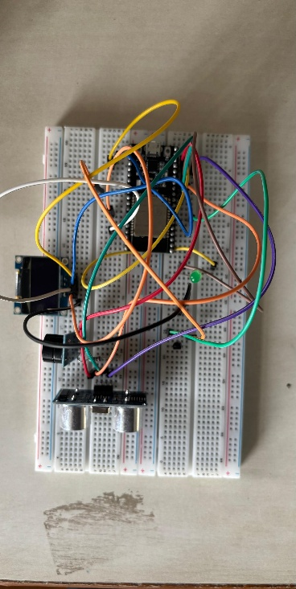

**Figure 3.6 Real-Time Circuit**

**3.7 Integration of Blynk IoT Platform for Remote Water Level Monitoring**

To enable remote monitoring and alert capabilities, the Blynk IoT platform was integrated into the water level detection system using the ESP32 development board. The Blynk app was configured with virtual pins corresponding to sensor outputs, such as the ultrasonic sensor’s measured distance. Through Wi-Fi, the ESP32 sends real-time water level data to the Blynk cloud, which is visualized on the mobile dashboard using widgets like gauges and notification alerts.

Threshold values were programmed to trigger warning messages when the water level fell below or rose above predefined limits. The app also allows manual control features like activating a buzzer or resetting the system remotely via buttons. This integration ensures users receive timely updates on water status and enhances safety by providing alerts for low water levels or potential overflow conditions. The Blynk platform’s ease of use and mobile accessibility make it ideal for smart monitoring applications in IoT-based water management systems.

In addition to monitoring, Blynk enabled interactive control of the system through mobile-based virtual buttons. For instance, users could trigger an emergency buzzer or manually refresh readings with a single tap. The data transmitted by the ESP32 was mapped to virtual pins in the Blynk app, allowing seamless visualization and remote control. This ensured both convenience and reliability, making the system suitable for use in household tanks, borewell monitoring, or agricultural irrigation setups where regular physical checks are impractical.

**CHAPTER IV  
SIMULATION AND RESULTS**

**4.1 SIMULATIONS OF THE SYSTEM IN DIFFERENT SCENARIOS**

1. **OLED DISPLAY VALIDATION**

| **Test No.** | **Water Level Status** | **OLED Display Output** | **Buzzer** | **LED Indicator** | **Result** |
| --- | --- | --- | --- | --- | --- |
| 1 | Normal | “Water OK” | OFF | Green | Pass |
| 2 | Low Level | “Refill Tank” | ON | Red | Pass |
| 3 | Overflow Detected | “Overflow Alert” | ON | Red Blinking | Pass |

**Table No. 4.1 I OLED Display Validation**

1. **SIMULATION OF THE PUMP IN REAL TIME**

|  |  |  |  |  |
| --- | --- | --- | --- | --- |
| **Date** | **Time** | **Water Level (cm)** | **Pump Status** | **Alert Sent** |
| 01-05-2025 | 09:00 | 120 | OFF | No |
| 01-05-2025 | 12:00 | 115 | OFF | No |
| 01-05-2025 | 15:00 | 110 | ON | Yes |
| 01-05-2025 | 18:00 | 105 | ON | Yes |
| 01-05-2025 | 21:00 | 108 | OFF | No |
| 02-05-2025 | 00:00 | 120 | OFF | No |
| 02-05-2025 | 03:00 | 125 | OFF | No |

**Table No. 4.2 II Simulation Of The Pump In Real Time**

**Graph No. 4.2 Graph depicting the table shown above**

1. **BLYNK NOTIFICATION RESPONSE TEST**

| **Test No.** | **Trigger Condition** | **Blynk Notification Message** | **Received on App?** | **Time Delay (s)** | **Result** |
| --- | --- | --- | --- | --- | --- |
| **1** | Water < 15 cm | “Low Water Level Detected” | Yes | 2 | Pass |
| **2** | Water > 65 cm | “Tank Overflow Warning” | Yes | 3 | Pass |
| **3** | Water Normal | No Notification | No | – | Pass |
| **4** | Sensor Disconnected | “Sensor Error: Check System” | Yes | 1.5 | Pass |

**Table No. 4.3 III Blynk Notification Response Test**

**CHAPTER V**

**IMPLEMENTATION**

**5.1 PRACTICAL IMPLEMENTATION OF THE PROPOSED SYSTEM**

This project can be implemented in multiple ways depending on the requirements. One approach uses Blynk and Wi-Fi, where the ESP32 continuously sends water level data to the app, allowing real-time remote monitoring and alerts.

Another implementation is an offline mode where the ESP32 triggers a buzzer and LED indicators to show water status without any internet. For advanced use, cloud integration enables logging data to platforms like Google Sheets or Firebase for tracking water usage patterns over time.

**Challenges faced:**

**Power Supply:** A major challenge in remote areas is ensuring a reliable and continuous power source for the IoT system. In many rural or isolated locations, there is limited access to the grid, making it necessary to rely on alternative power sources, such as solar panels or batteries. However, these solutions often face issues with energy efficiency, storage, and weather dependence. Balancing power consumption and ensuring that the system remains operational during extended periods of low sunlight or poor weather conditions can complicate the design.

**Integration of Components:** Another challenge lies in integrating various components like sensors, communication modules (GSM, LoRa, etc.), and the central IoT platform. Ensuring compatibility and smooth communication between these different hardware and software parts can be complex. Each component must be properly configured, and any issues with communication protocols or signal interference can disrupt data flow or lead to malfunctioning of the system.

**Sensor Accuracy and Durability:** The sensors used in the borewell system need to provide accurate measurements of parameters such as water level, temperature, and pressure. However, environmental factors such as temperature fluctuations, humidity, or the presence of chemicals in the water can affect sensor accuracy. Additionally, the sensors must be durable enough to withstand the harsh conditions of being submerged in water or exposed to the outdoor environment for long periods. Regular calibration and maintenance of the sensors are crucial to ensure data reliability.

**Data Transmission:** The success of an IoT-based borewell monitoring system heavily depends on the ability to transmit data reliably in real-time. In remote or rural locations, the lack of strong cellular or Wi-Fi connectivity can lead to difficulties in maintaining consistent data flow from the borewell to the monitoring system. Choosing the right communication protocol, like GSM, LoRa, or satellite, can mitigate this issue, but each comes with its own set of challenges, such as range, data speed, and costs.

**CHAPTER VI**

**CONCLUSION**

The IoT-based borewell monitoring system successfully measured and transmitted key parameters such as water level, temperature, and pressure. The sensors provided accurate readings, and the data was transmitted to the central monitoring system via Blynk, with minimal latency. The system operated reliably, with no significant downtime during the testing period.

The power supply, primarily sourced from the main grid, was stable, and the system performed continuously without interruption. Blynk effectively facilitated real-time data transmission, and users received alerts and updates promptly. In locations with stable internet connectivity, the data transmission was seamless, though occasional network instability led to brief delays in data updates.

Sensor accuracy was maintained throughout the testing period, with regular calibration ensuring reliable performance. There were minor discrepancies in the readings, particularly due to temperature fluctuations and water turbidity, but these did not significantly affect the overall system performance.

**REFERENCES**

1. XuJian-Hua; Luo A-Ling “Research on Water Resources Automatic Monitoring and Management System”. Publisher IEEE. Fourth International Conference on Computational and Information Sciences (ICCIS), 2012 Date of Conference: 17-19 Aug. 2012 Page(s): 1135-1138.
2. Jiang Wei, “Intelligent Building Control of Water Tank Based on Fuzzy Theory”. Publisher IEEE International Conference on Intelligent Computation Technology and Automation (ICICTA), 2010 (Volume:2 ) Date of Conference:
3. 11-12 May 2010. Page(s): 549 – 552.
4. ESP-32 DATASHEET Espressif Systems
5. https://www.handsontec.com/dataspecs/HC-SR04-Ultrasonic.pdf
6. <https://www.researchgate.net/publication/343285722_Review_on_IoT_based_water_level_sensing_and_controlling>
7. <https://www.electroniclinic.com/iot-based-water-level-monitoring-system-using-esp32-waterproof-ultrasonic-sensor-new-blynk/>
8. <https://iotcircuithub.com/iot-based-water-level-indicator>
9. <https://lededitpro.com/build-a-water-level-control-system-using-esp8266-nodemcu>